

**Prepared By: Rampalli Charan  
Version: 1.0**

**Automation Testing Project Report – nopCommerce**

**1. Introduction**

Automation testing is a crucial part of modern software development to ensure quality, reliability, and efficiency. Manual testing can be time-consuming and error-prone, especially for repetitive tasks.

This project focuses on automating the functional testing of the **nopCommerce e-commerce platform (**[**https://demo.nopcommerce.com**](https://demo.nopcommerce.com)**)** using **Selenium WebDriver and Java**. nopCommerce is an open-source online shopping platform that allows users to browse products, manage accounts, place orders, and generate reports.

The automation project aims to reduce manual effort and testing time through automation, validate essential workflows like user registration, login, product selection, and adding items to the cart, implement a data-driven approach using Excel for multiple test scenarios, and apply Page Object Model (POM) design for maintainable and scalable automation.

This report documents the automation process, including tools used, test strategy, results, challenges, and recommendations for future enhancements.

**2. Objective**

The main objectives of the project are to automate the functional testing of nopCommerce website modules, validate key workflows including user registration, login, product selection, and cart operations, ensure consistent execution and error-free performance across critical modules, implement a data-driven approach for executing multiple input scenarios using Excel, and validate the shopping cart and checkout process with billing address.

**3. Project Overview**

nopCommerce is an open-source e-commerce platform used globally for online retail. Automation testing ensures reliable functionality, improves efficiency, and reduces errors.

The project emphasizes automating repetitive tasks such as registration, login, and product management, validating the application’s behavior under multiple scenarios, and using Excel as a source for test inputs and expected outcomes, enabling data-driven testing.

The technologies and tools used in the project include Selenium WebDriver, Java, TestNG, Apache POI for Excel integration, Chrome Driver, and Eclipse IDE.

**4. Project Scope**

**In Scope:** The project covers Admin login and logout, dashboard access and verification of widgets, menus, and notifications, customer management including add, edit, delete, and search records, product management including add, edit, delete, and verification of product details, order management and processing including creation, updates, and status verification, reports and analytics generation and validation, shopping cart validation, and checkout process including billing address.

**Out of Scope:** The project does not cover payment gateway integration or performance and stress testing.

**5. Tools & Technologies**

The automation is implemented using Selenium WebDriver as the testing tool, Java as the programming language, TestNG for test management, and Apache POI for Excel data integration. The testing was performed on the latest version of Google Chrome, and Eclipse IDE was used for development.

**6. Test Strategy**

The test strategy ensures systematic validation of functional workflows through automation. Repetitive workflows are automated while exploratory or edge cases are tested manually.

Test levels include smoke testing to validate critical modules after each build, functional testing to verify individual feature functionality, and regression testing to re-run automated tests after updates to ensure stability. Test data is maintained in Excel sheets containing valid and invalid inputs for registration, login, product selection, cart actions, and checkout. The testing environment uses the latest stable version of Chrome browser.

**7. Test Scenarios (High-Level)**

The key functional test scenarios include launching the browser and navigating to the homepage to verify the title, logo, and navigation; user registration with valid and invalid data to validate success messages and error handling; user login with valid and invalid credentials; submodule verification to ensure Electronics, Apparel, Books, and other modules load correctly; product selection and adding products to the cart; shopping cart validation to verify cart contents and product details; and checkout process validation including billing address entry and order placement.

**8. Automation Workflow**

The automation workflow begins with the Launch Browser test case, where the browser is opened, maximized, and navigated to the nopCommerce homepage. The homepage title and logo are verified to ensure the application has loaded correctly. Next, the Register User Successfully test case is executed, where the user completes the registration form with valid details. The form submission is verified to ensure a success message is displayed, confirming the user account has been created. Following registration, the Login User Successfully test case validates that a registered user can log in using valid credentials. Login error handling is also verified using invalid or empty credentials, and the presence of the “My Account” section confirms successful login.

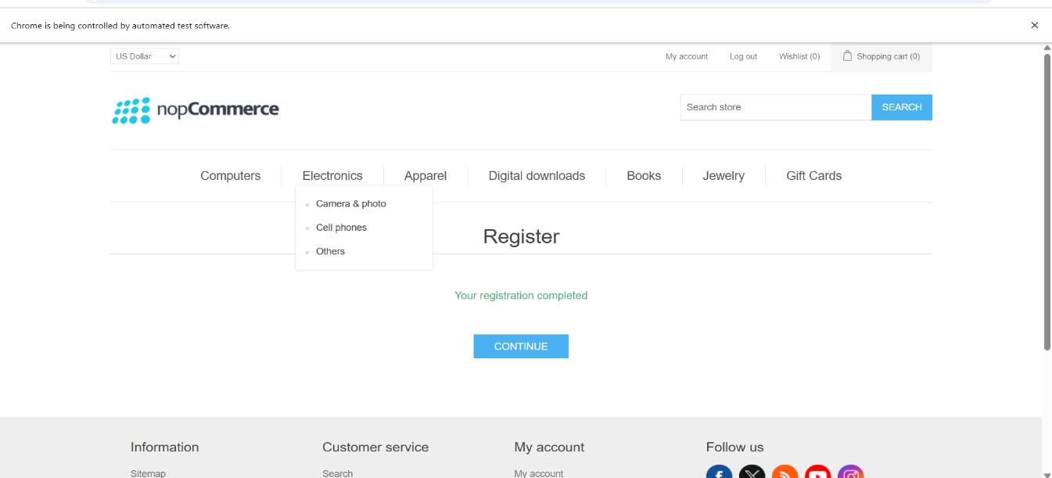

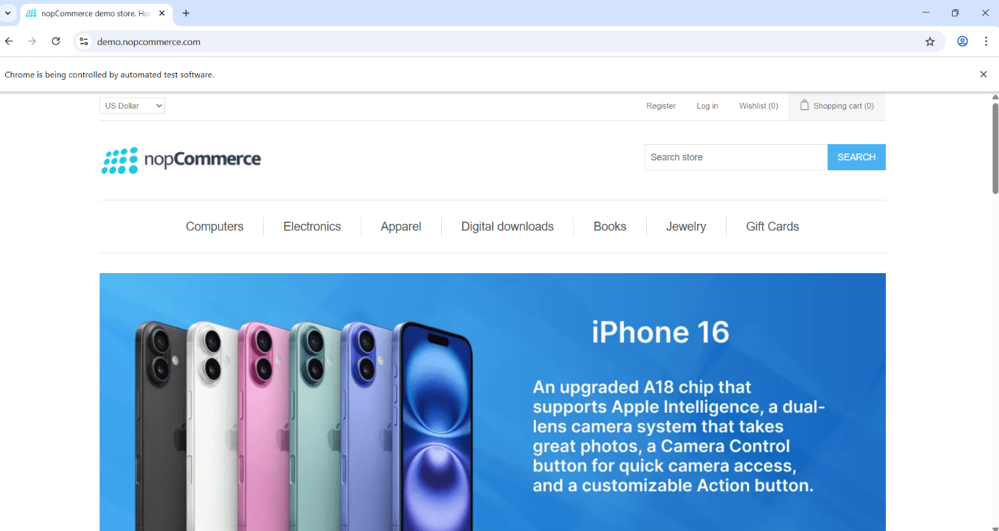

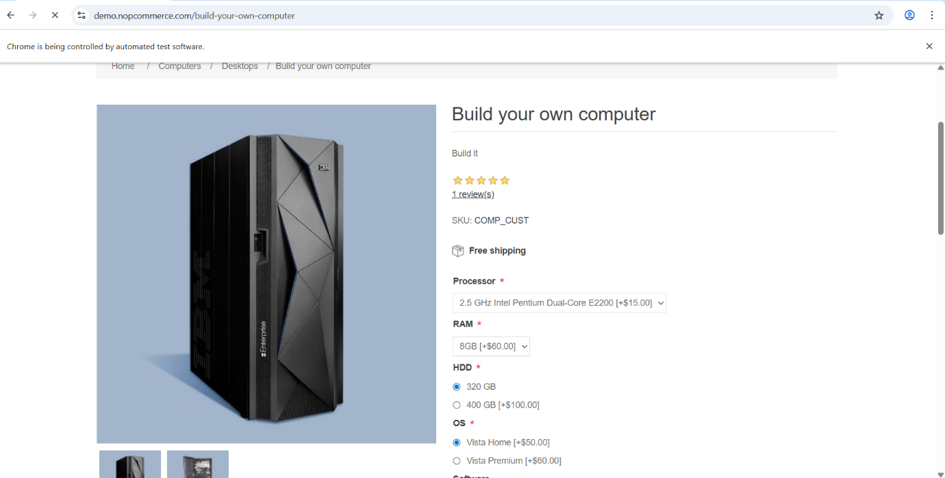

The Add Product to Cart test case involves navigating to product categories, selecting a product from the dropdown menu or using radio buttons, or directly from the product page. The selected product is added to the cart, and the quantity is increased to two to validate cart updates. In the Open Shipping Page and Enter Shipping Address test cases, the shopping cart is accessed, and the shipping page is opened. The user enters the billing and shipping details, ensuring the fields are correctly validated. The Proceed to Checkout test case follows, where the order is reviewed, the payment method is selected, and the order is confirmed. The workflow also includes navigating through other modules like Digital Downloads and Books, ensuring that submodules load correctly and product navigation works as expected. Each test case is executed sequentially to ensure end-to-end functional validation of the nopCommerce platform, with screenshots captured for critical steps and successful validations recorded. This workflow ensures that all essential features, from browser launch to checkout, are tested efficiently using automation.

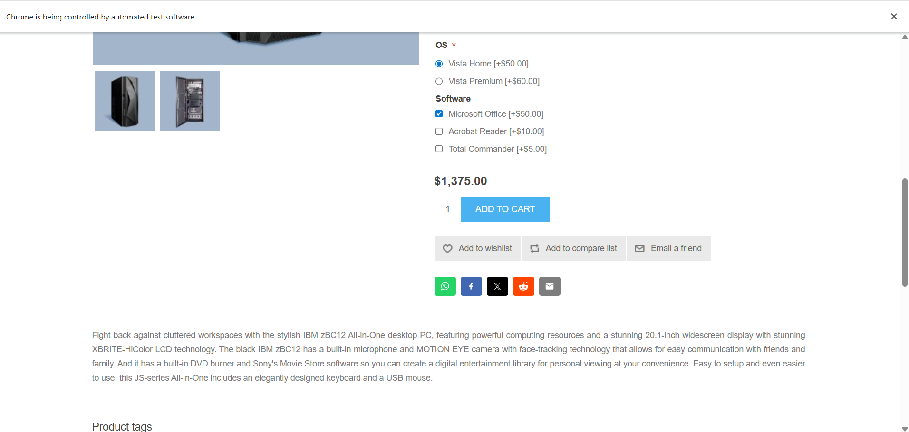

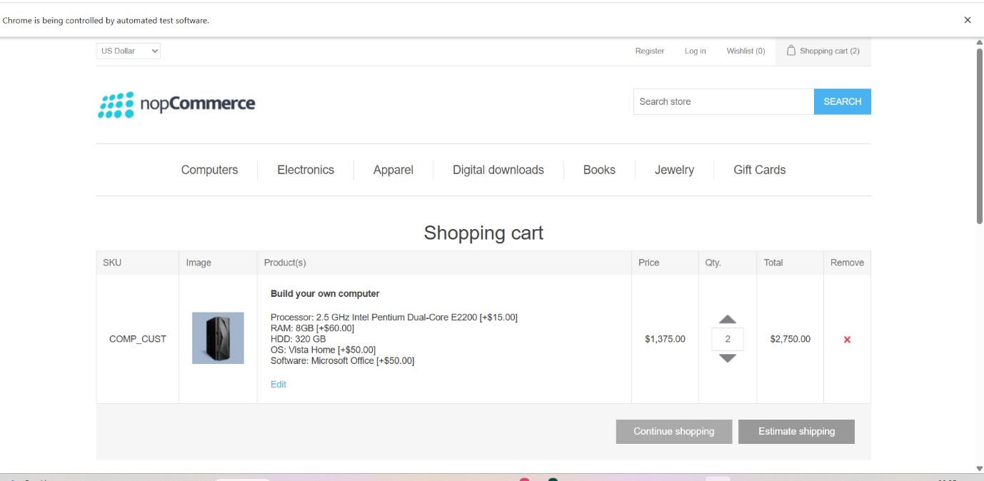

**8.1. Test Execution and Observations**

A total of 17+ test cases were executed with a 100% pass rate for all critical functional workflows. Registration and login modules executed successfully. Submodules, product selection, and Add to Cart workflows were verified without issues. Screenshots were captured for key steps as evidence. Shopping cart and checkout workflows executed successfully, validating the end-to-end order process.

**9. Challenges & Solutions**

Dynamic web elements were handled using explicit waits to ensure stability. Synchronization issues were solved with WebDriverWait. Excel data integration was managed efficiently using Apache POI, supporting multiple sheets for different input scenarios.

**9.1 Conclusion**

Automation significantly reduced testing time and manual effort. All critical workflows of nopCommerce including registration, login, product selection, shopping cart, and checkout were validated successfully. The project demonstrated effective end-to-end automation using Selenium and Java, providing a strong foundation for expanding automation to additional modules and future enhancements.

**9.2 Future Enhancements**

Future enhancements include extending automation to include payment gateway and additional checkout workflows, implementing cross-browser testing for wider coverage, and integrating the automation suite with CI/CD tools such as Jenkins for continuous testing.

**10. References**

* Selenium WebDriver Official Documentation
* TestNG Official Documentation
* nopCommerce Website for Functional Details